

Guidance for parents and carers
SUPPORTING YOUR CHILD WITH THE END OF KS2 ASSESSMENTS

Guidance for parents and carers
Supporting your Year 6 child with the end of Key Stage 2 assessments
Dear Parents and Carers,
As you know, the Year 6 Key Stage 2 tests (commonly known as SATs) take place in May. Whilst we are working hard at school to prepare your child for these assessments, we value any support that you can give them.
In this booklet, we have outlined some of the things which you can do at home, or whilst out and about, to help to prepare your child, not only for the tests but also for their transition to secondary school. Helping them to improve knowledge and skills is important but just as key are the personal things like encouragement, as well as making sure they have a healthy lifestyle, eat well and sleep well!
We hope you find this helpful. Please contact us if you have any questions or you would like any further ideas on how to prepare your child for these tests.
Many thanks for your support!
The Year 6 team


Helping your child at home
English
- Continue to read with your child every day, discussing the book as you read it.
- Try to help your child to improve their reading speed by reading an extract from a suitably challenging text. Time them and then repeat. Can they beat their time? Ask questions about the extract to check their understanding.
- Give your child timed challenges when reading. For example, how many adverbs/adjectives can you find in 2 minutes?
- Play games to develop their vocabulary and spelling. Try games like Scrabble, Boggle, Pictionary and Taboo. What does the word mean? Can they spell it? Can they use it in a sentence? Use the PiXL Unlock app (see Toolbox section) to develop their vocabulary.
Mathematics
- Use the receipt from your shopping to ask questions e.g., what is the total cost of the fruit and vegetables? What change would I get from £50? While unpacking the shopping, guess the weight of items then weigh them.
- Use the Mental Maths app (see Toolbox section) to practise times tables daily. Can your child recall their facts instantly? Compete against themselves or others to improve their speed!

- Newspaper maths – use league tables or weather charts in newspapers to ask questions e.g., what is the difference between the temperature in London and Moscow? What is the mean (average) of the points scored in the Premier League?
Helping your child on the move
English
- Listen to the lyrics of songs on the radio. Can they identify the adjectives? Can they give a synonym (a word with a similar meaning) or antonym (opposite meaning) for one of the words?
- Look at objects and places they pass while travelling. Pick out a word and play ‘Just a Minute’ where your child must explain what the object is without using the word itself and without hesitating or repeating themselves.
- Telling a story together. Give the first line of a story and take it in turns to continue it. Begin each sentence with a conjunction e.g., next, after that, after a while, finally …

Mathematics
- Number plates – Look at the numbers on number plates and create questions based on them e.g., subtract the number from 1000 or multiply/divide the number by 10/100 or 1000.
- Sequences – Choose a starting number and a rule. Take it in turns to say the next number in the sequence e.g., start with 19 and add/subtract 8. How far can you take the sequence before an error is made? Try decimals too.

- Odd one out – Give your child four numbers and ask them which is the odd one out and why e.g., 12, 19, 18 and 21. 19 is the odd one out because it is the only prime number.
Helping your child when out and about
English
- When visiting somewhere, challenge your child to come up with ‘Pointless’ adjectives. In other words, an adjective that no-one else would think of e.g., a monumental tree, a formidable skate-boarding slope.
- Practise standard English by pretending that you are a visitors’ guide and explaining the key highlights of the place using correct standard English.
- Select an object at the place and take it in turns to see how many antonyms or synonyms you can think of for the word e.g., an antonym of steep is gentle; a synonym could be sheer.
Mathematics
- How long? Select a starting and finishing point in the place. Estimate how many seconds/minutes it would take to walk the distance, then time it. What is the difference between the two times? Who was the closest?
- I-spy – Play the game by describing the properties of a shape which can be seen e.g., I-spy a quadrilateral with only one pair of parallel lines (a trapezium).
- How much? Use entrance fees or a menu to create questions. How much would it cost for 2 adults and 2 children? What would be the change from £50?


Supporting your child’s wellbeing
- Encourage your child to take plenty of exercise. Why not go out for a walk together after your evening meal? What about a bike ride at the weekend?
- Breakfast is the most important meal of the day. Why not create some healthy breakfast menus together? Or try some of the healthy smoothie recipes from the ‘Power to Perform’ booklet?
- Device-free time – why not challenge your child to spend an hour each evening away from screens and electronic devices? What about playing a board game instead or going outside to play?
- Try to make sure your child has a regular routine for going to bed and getting up so that they have between 9 and 10 hours of sleep each night (approximately).
- If they are learning at home, a quiet place away from distractions is ideal. Try to encourage them to take the ‘little and often’ approach, and take regular breaks.

- Encourage your child to share with you their feelings as they begin the final term of primary school. Help them to understand that experiencing a mixture of feelings – excitement, nervousness, optimism, worry – is completely normal.
Parents’ Toolbox
The resources below can be used to support your child in preparing for the tests and ensuring they have the right knowledge and skills to make a good start at secondary. Please ask your child’s teacher for those listed as PiXL resources.

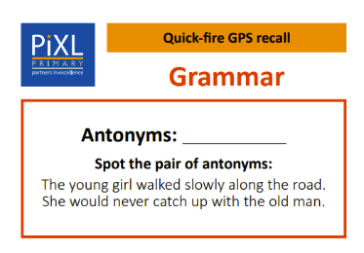
PiXL Resources
- GPS recall cards
- Error and misconceptions cards (GPS and Mathematics)
- Power to Perform pupil booklet
- Holiday Challenges (10 for 10)

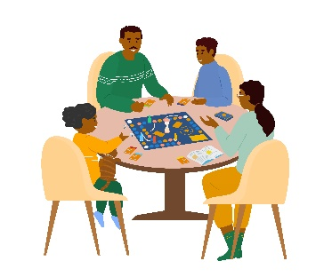
Games
- Taboo
- Pictionary
- Boggle
- Scrabble
- Articulate
- Monopoly

Useful websites: English

- Ed Shed
- https://www.bbc.co.uk/bitesize/subjects/zv48q6f/year/zncsscw
- https://www.oxfordowl.co.uk/for-home/advice-for-parents

Useful websites: Mathematics

- Stick and split online game
- Times tables rockstars online game
- https://www.bbc.co.uk/bitesize/subjects/z826n39/year/zncsscw

What are the end of Key Stage 2 tests?
Children in Year 6 will be taking the Key Stage 2 tests in May 2024. They provide information about how your child is progressing and how they compare to children of the same age nationally. They provide a ‘snapshot’ of your child’s learning, progress and attainment at the end of KS2. These tests are both set and marked externally.
The tests are not qualifications and don’t affect your child’s future options in school. However, they do help to develop key skills which provide an important foundation for secondary school.
When do the end of Key Stage 2 tests take place?
Date | Paper | Duration
Monday 13th May 2024 | English Grammar, Punctuation and Spelling (GPS) Papers 1 and 2 | 45 minutes (GPS)  Approx. 15 minutes (Spelling)
Tuesday 14th May 2024 | English reading | 1 hour
Wednesday 15th May 2024 | Mathematics Paper 1 (Arithmetic) and Paper 2 (Reasoning) | 30 minutes (Paper 1)  40 minutes (Paper 2)
Thursday 16th May 2024 | Mathematics Paper 3: Reasoning | 40 minutes

What is involved in the tests?
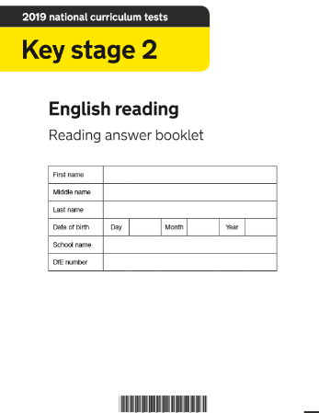
The Reading Test
- Three passages of text which get progressively more difficult
- A total of 50 marks
- A variety of question types
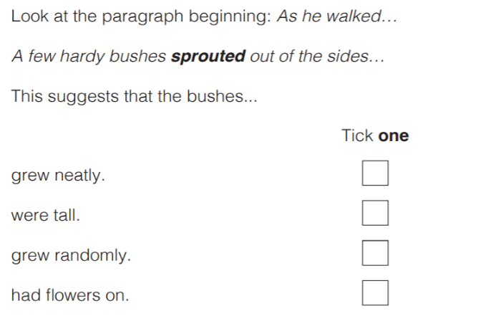

The Grammar, Punctuation and Spelling (GPS) Test
- Paper 1 assesses grammar and punctuation (50 marks)
- Paper 2 assesses spelling (20 words)
- A variety of question types

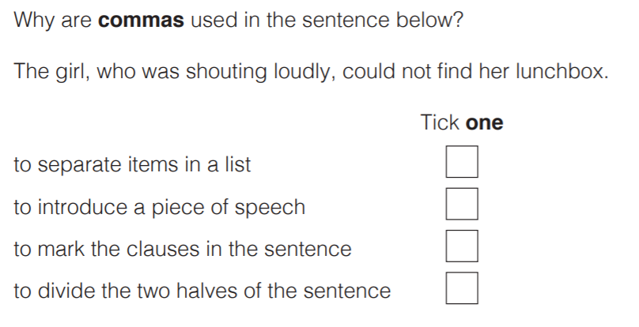
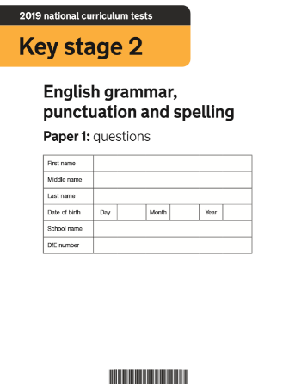

The Arithmetic Test
- 35 questions
- No context to the questions, so there is no reading needed
- Some can be solved mentally, others require jottings or written methods
- Long multiplication and long division are worth 2 marks (all other questions are worth 1 mark)
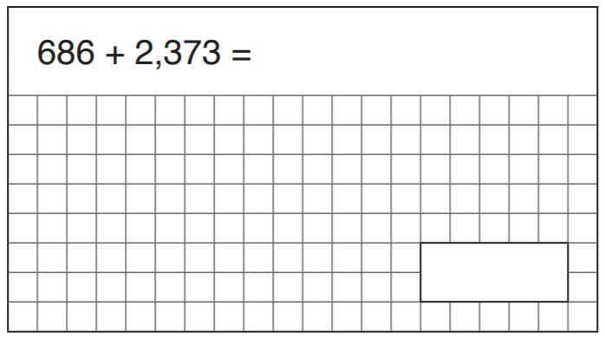
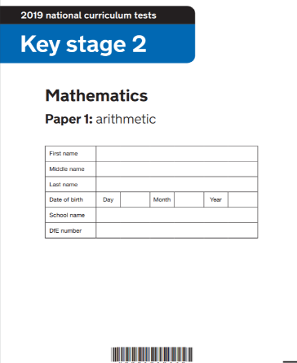

The Reasoning Tests
- 35 marks per paper
- They assess mathematical problem solving and reasoning
- Calculators not allowed
- A significant amount of reading needed

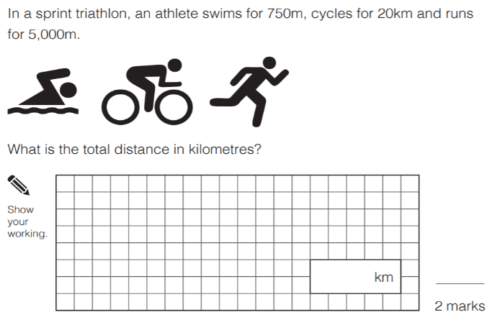
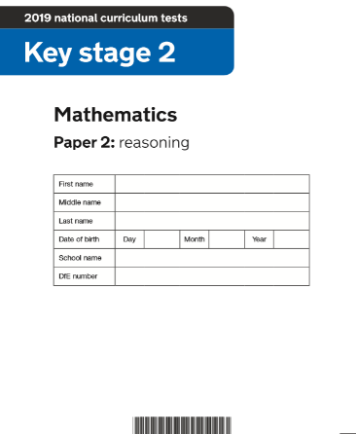

There is no writing test – this is assessed by your child’s teacher.

